Detection of Cyberbullying on Social Media using Machine Learning
In this project as per your request we have used given dataset to train machine learning algorithms such as ADABOOST, Multinomial Naïve Bayes and SGD to predict cyberbully from user post messages. SVM classifier is used to predict sentiments.
This project consists of two users
- Admin user: admin can login to application by using username and password as ‘admin’ and ‘admin’. After login admin can view list of users and their count of offensive messages posted by them. If count is more than 2 then Block linked will get activated and then admin will block him. Admin can view accuracy and other metrics from trained model.
- User: user can signup with the application and then can login and then can upload post. While uploading application will detect sentiments and check for offensive words.
To run project install python 3.7.0 and then install MYSQL and then copy content from ‘DB.txt’ and paste in MYSQL to create database.
Now double click on ‘runServer.bat’ file to start server and get below screen
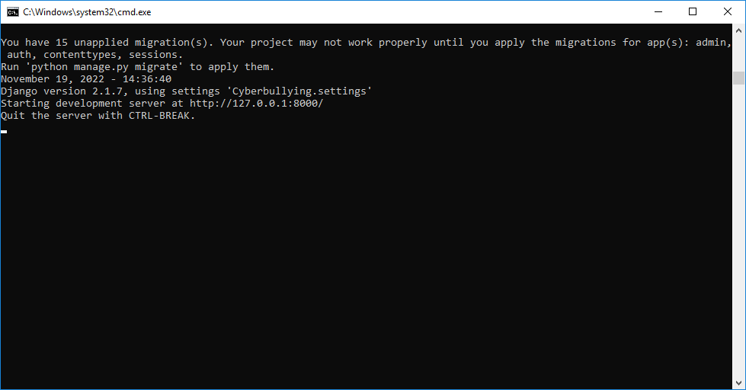
In above screen server started and now open browser and enter URL as ‘http://127.0.0.1:8000/index.html’ and press enter key to get below page
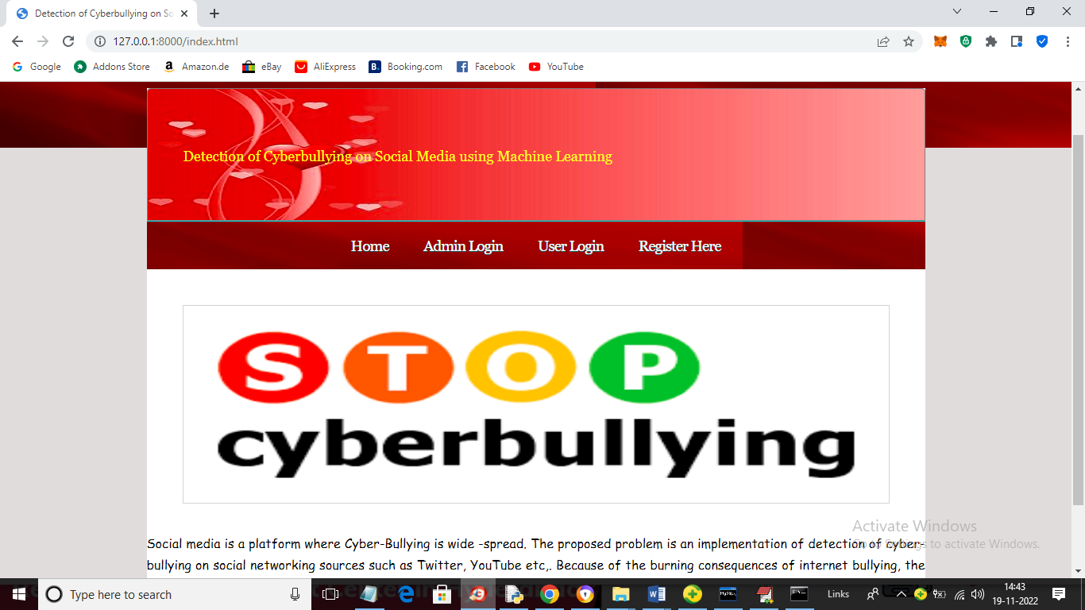
In above screen click on ‘Register Here’ link to get below signup screen
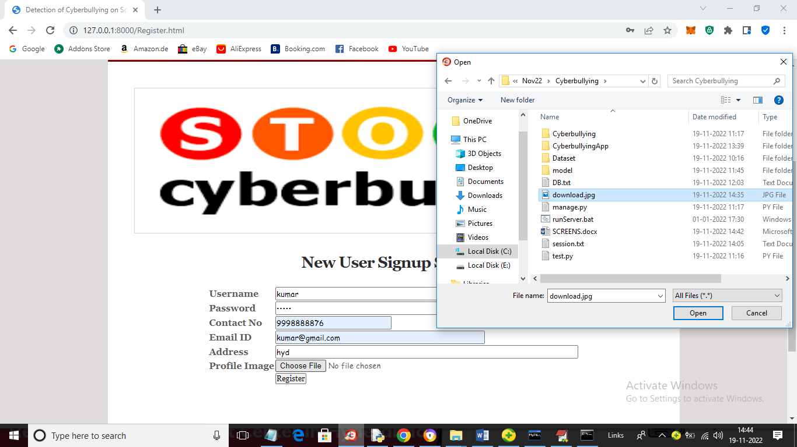
In above screen signup user and then uploading profile picture and then click on ‘Open’ and ‘Register’ button to complete signup task and get below output
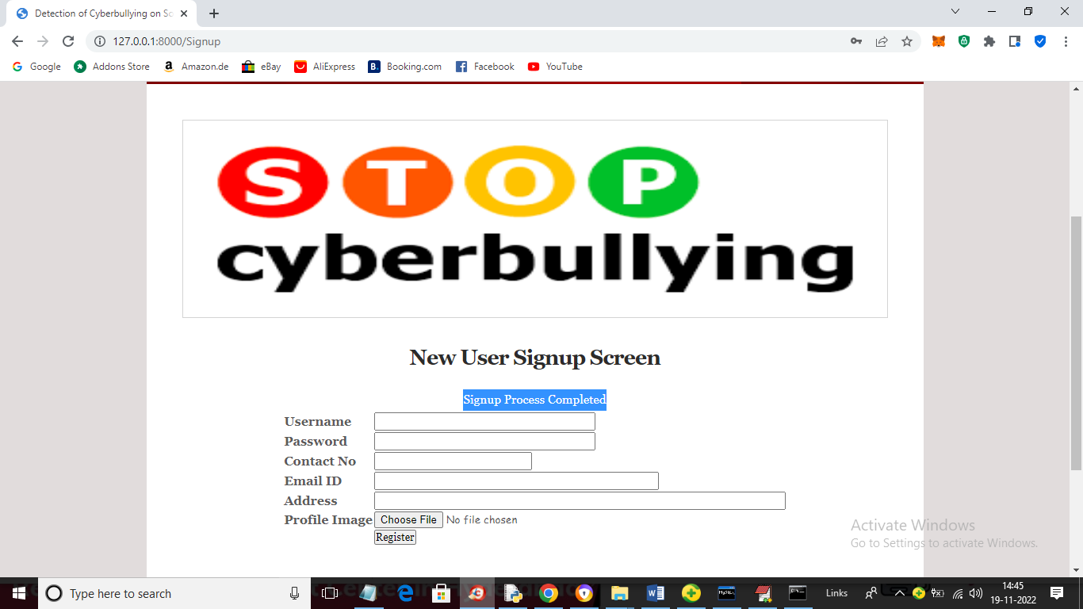
In above screen signup process completed and now click on ‘User Login’ link to get below screen
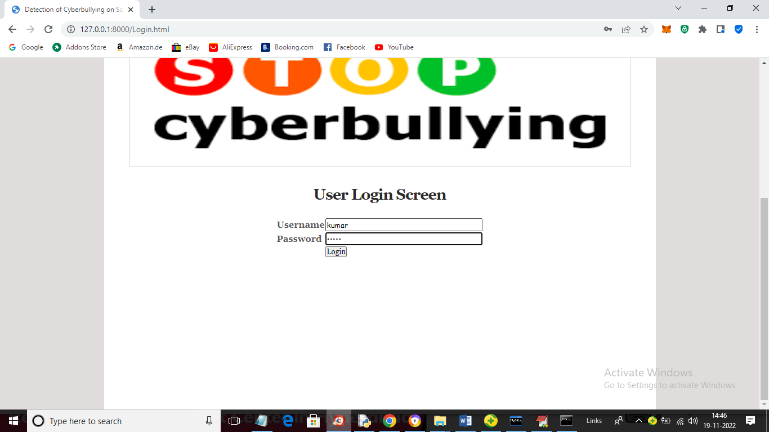
In above screen user is login and after login will get below page
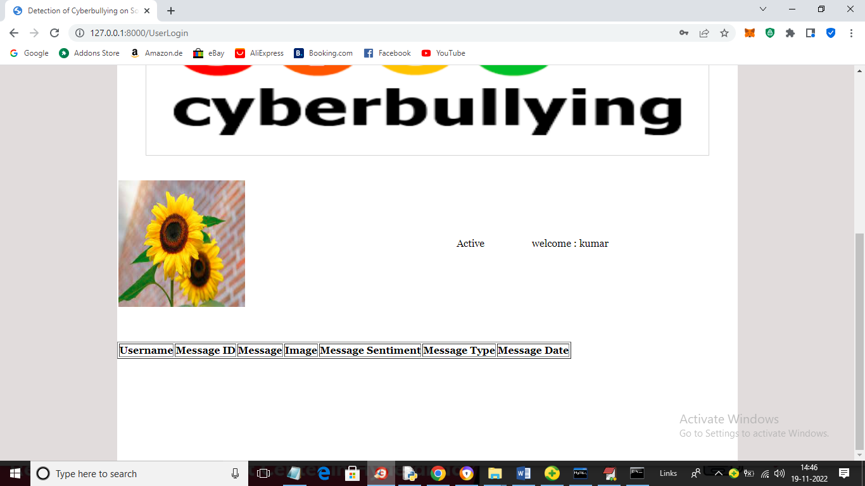
In above screen we can see user profile picture and then can see list of messages posted by user and now no user posted so table is empty and now click on ‘Post Topic’ link to post messages and get below page
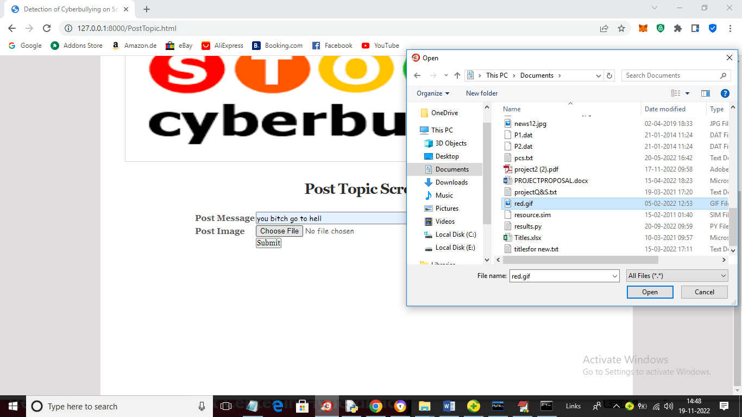
In above screen I entered some message and then uploading image for post and we can see message contains bullying words so will get below output from classifiers
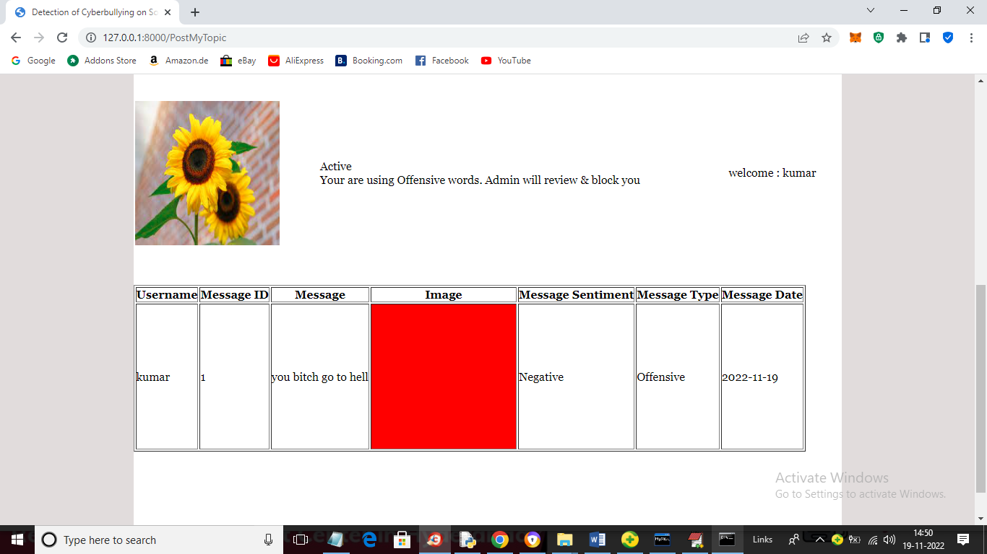
In above screen user message is uploaded and we can see message sentiments detected and Negative and Offensive and now I will upload another post and in above screen we can see application displaying ‘Offensive words are using and admin will block account’. Offensive messages count will get saved in his profile which admin can see.
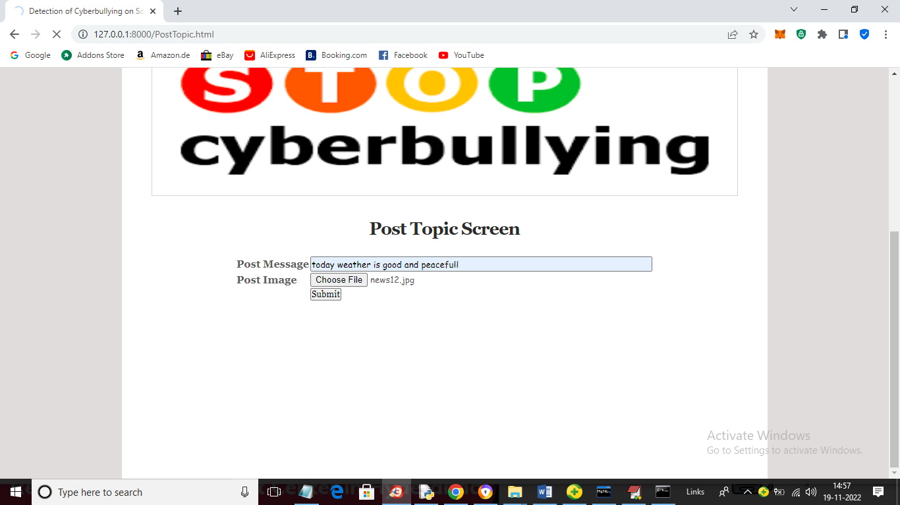
In above screen posting normal message and after analysing will get below output
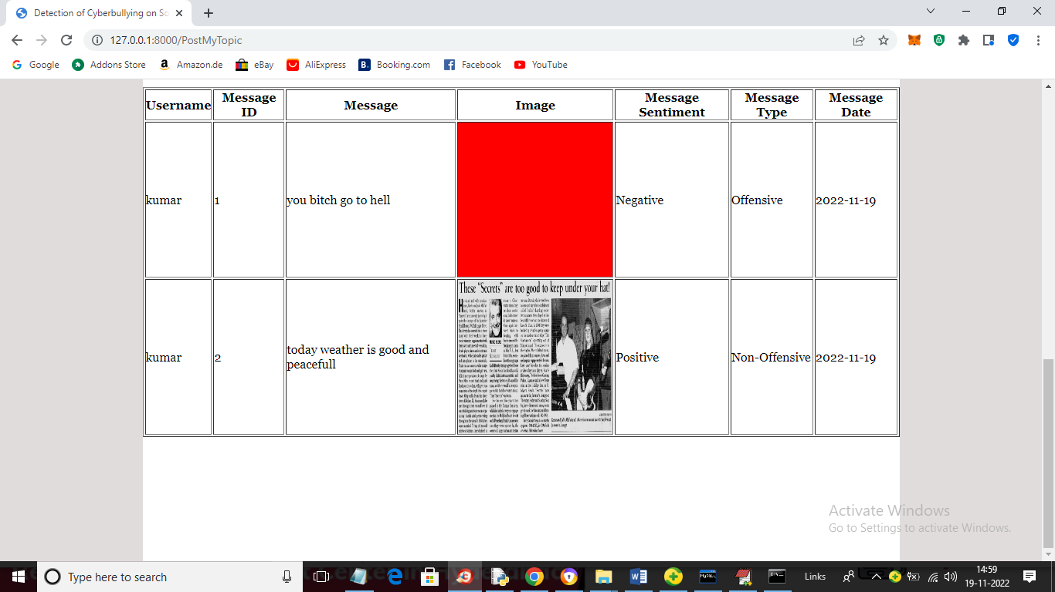
In above screen second message is predicted as ‘Positive’ and ‘Non-Offensive’ and similarly you can upload other messages also. (Note: classifier will predict only those message as offensive or non-offensive whatever available in dataset). Now logout and login as ‘admin’ to view list of users.
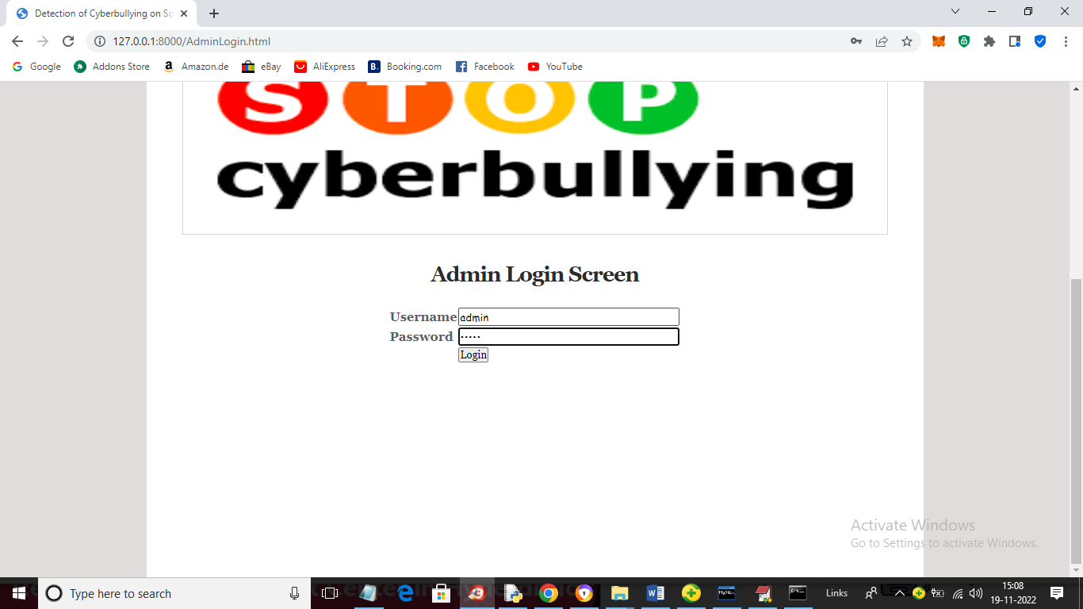
In above screen admin is login and after login will get below page
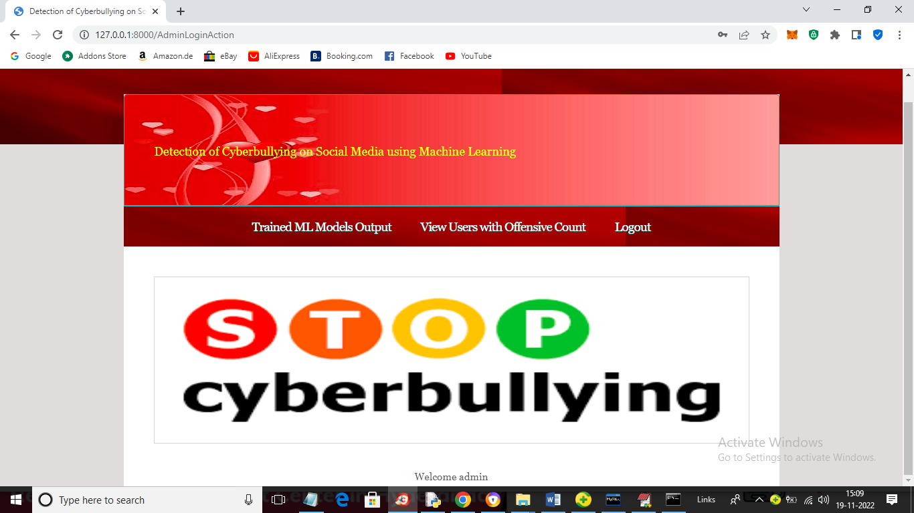
In above screen click on ‘Train ML Models Output’ link to get accuracy and other output
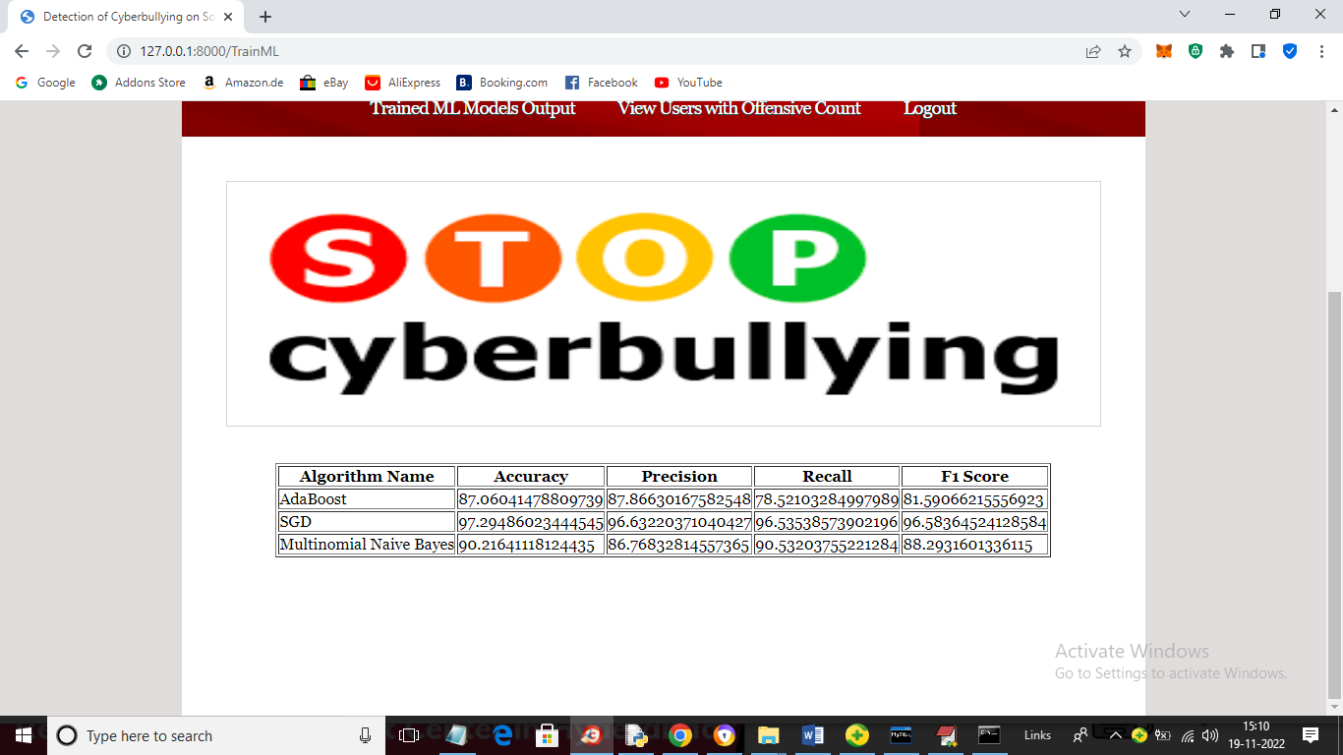
In above screen for each algorithm we can see accuracy and other metrics and now click on ‘View Users with Offensive Count’ link to get below pages
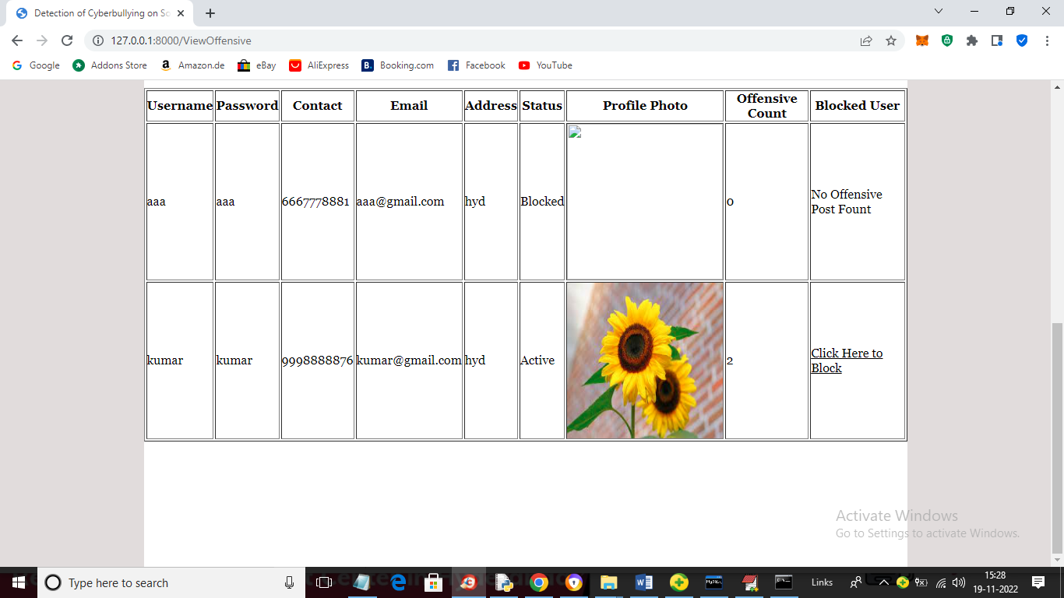
In above screen admin can see one user ‘aaa’ offensive count is 0 and kumar offensive count is 2 and ‘Block’ link activated and admin can click that link to block that user and get below page
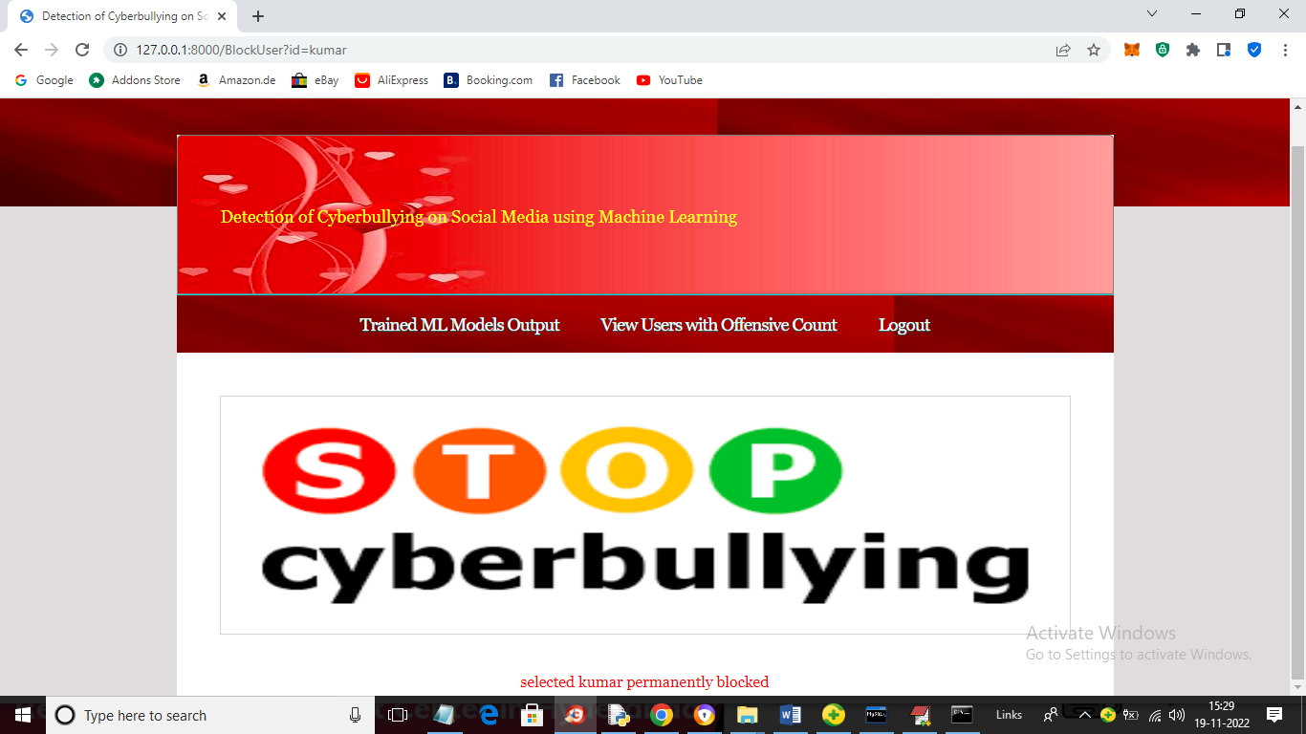
In above screen in red colour text kumar user blocked and now try to login with kumar and get below output
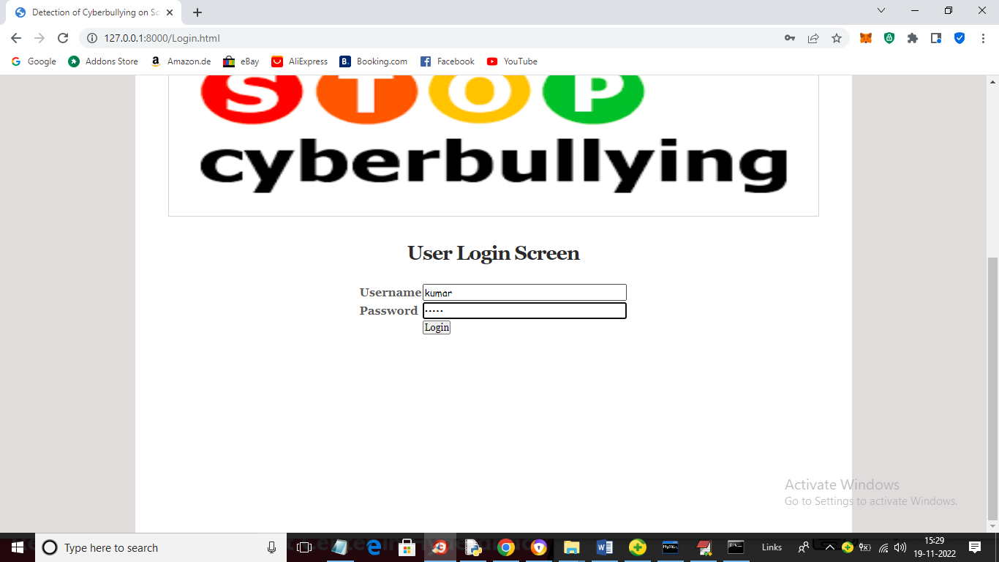
In above screen kumar is login and after login will get below page
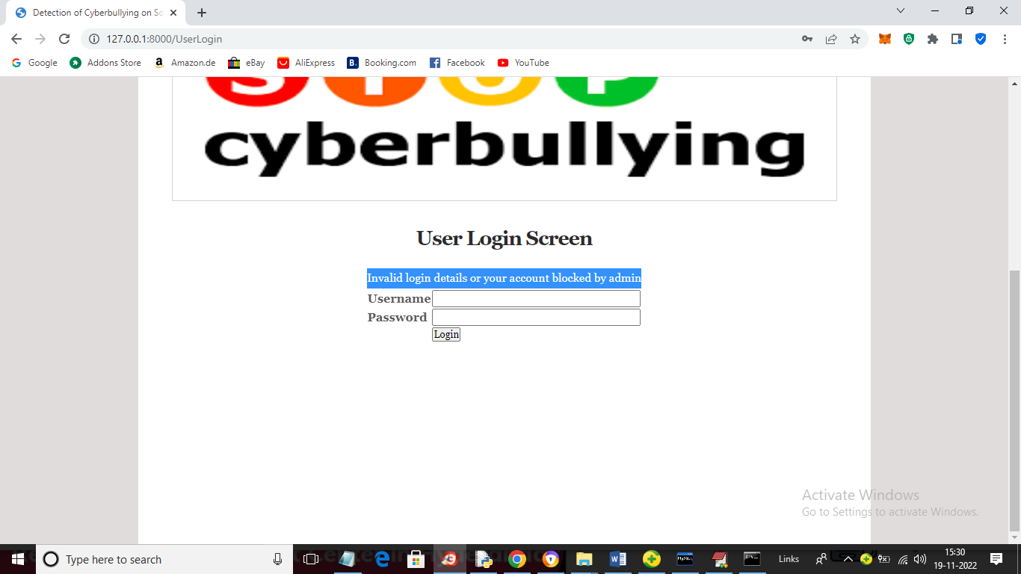
In above screen we can see account is blocked.
Similarly you can post message and detect sentiments and bullying. While uploading messages don’t give special symbol like apostrophy ‘.

